|  |  |
| --- | --- |
| **Name** |  |
| **Tutor/Department** |  |

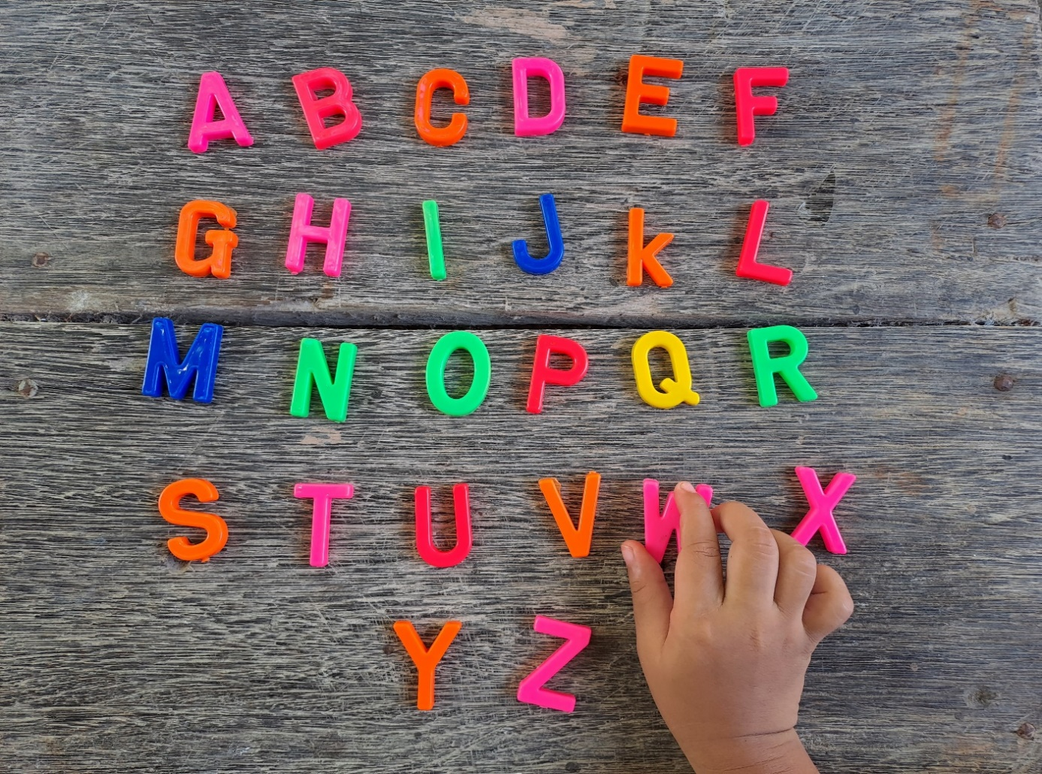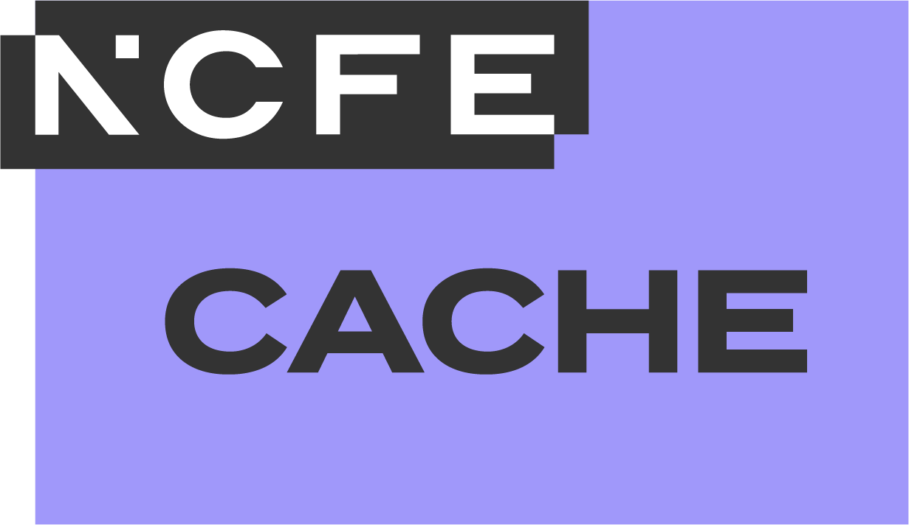

**Glossary**

**Level 3 Early Years Educator**

**Copyright notice**

© NCFE 2024. All rights reserved. No part of this document may be reproduced, distributed, or transmitted in any forms or by any means, including photocopying, recording, or other electronic or mechanical methods, without the prior written permission of NCFE.

NCFE resources available in a digital format can be adapted to learners’ needs but trademarks, copyright or other proprietary notices cannot be deleted or modified without permission.

The content of this document is, unless otherwise indicated, the intellectual property of NCFE. Users are permitted to view, print, and download the material for personal, non-commercial and classroom use (i.e. non-commercial use by a qualified educational institution) only. Users are not permitted to remove or amend trademarks, copyright, or other proprietary notices.

|  |  |
| --- | --- |
| Version | Publication year |
| V1.0 | 2024 |

**Disclaimer**

NCFE resources are optional support tools and are not essential to the delivery of the relevant qualification. They provide an interpretation of how the subject content listed in the Qualification Specification can be delivered. They are written and reviewed by subject experts independently to the Qualification Specification and to the assessment materials. The content included in these resources does not indicate any content coverage in summative assessment materials.

Centres must refer to the Qualification Specification for the relevant qualification for full details of the mandatory content of the qualification. The teaching guidance section of the Qualification Specification is advisory and provides useful guidance to support delivery of the teaching content of the qualification.

The content of these resources is correct at the time of publishing but may be subject to change.

# Contents

Contents 2

Introduction 3

Contact us 24

# Introduction

This document provides an alphabetical list of key terms from the Level 3 Early Years Educator qualifications.

Learners are invited to utilise this document as a quick and accessible reference point for meanings of key concepts referred to throughout these qualifications.

This document is fully editable and providers can choose to adapt and shape as required.

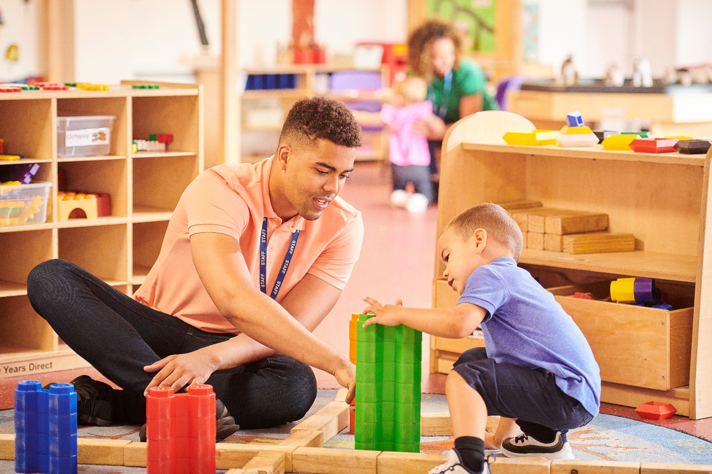

**Abuse:** ill treatment of a person or thing.May be physical, emotional, domestic, online or sexual. Also includes neglect and exploitation (see also **Harm**).

**Accidents:** incidents that happen without a particular deliberate cause and (in this context) that may cause harm to someone or something (see also **Near misses**).

**Accurate and coherent records:** records may include dietary needs, medication requirements, assessments and observations, health, accidents and near misses and registers. These records must be clear and correct.

**Additional needs:** these can relate to communication, behavioural, emotional wellbeing, learning or developmental conditions where additional support (intervention) is needed. Intervention could be short term, such as a planned transition and may not indicate a recognised special educational need or disability. Short-term regression or changes in behaviour, withdrawn behaviour, inappropriate behaviour and delays do not necessarily indicate special educational needs and disabilities (SEND). These may indicate a gap in knowledge or understanding. However, any indications of additional need should alert the professional to monitor progress and intervene as appropriate.

**Adult explanations:** communication with children that must be clear, age and stage appropriate and adapted to suit the needs of the individual. When talking to parents or carers the communication must also be jargon-free, clear and straightforward.

**Adult-led explicit teaching:** adult-led structured activities which are typically planned to meet specific outcomes or criteria (see also **Child-initiated experiences**).

**Adult modelling:** in this context,the modelling of best practice including roles and responsibilities as well as the scaffolding of learning for children.

**Adverse childhood experiences:** early experiences in childhood and adolescence that can impact on how individuals respond in particular situations when triggers are heightened. This can leave individuals unable to manage feelings and situations as expected. Terms such as freeze and fight, flight or freeze are often associated with adverse childhood experiences (see also **Trauma**).

**Age-appropriate boundaries:** in the context of professional relationships with babies, young children and their families, this can refer to maintaining professional standards and policy and procedures in the setting. It is always important to appreciate the age and stage and individual needs of the child when considering expectations. Professionals working with children must always work within professional boundaries.

**Anaphylaxis:** a severe allergic reaction which may be fatal if not treated (see also **Common childhood allergies**).

**Appropriate supervision of children in a setting:** babies and children must be supervised in adherence with the statutory requirements for ratios.

**Areas of learning:** with reference to the child, this includes cognitive development, physical development, neurological and brain development and speech, language and communication. There are seven areas of learning in the context of the early years foundation stage (EYFS). The three prime areas of learning are communication and language, social and emotional development, physical development and personal development. The four specific areas of learning are mathematics, literacy, understanding the world and expressive arts and design.

**Assessment methods and techniques:** the range of ways to check on a baby or child’s development, such as direct observation or asking questions (see also **Assessment opportunities** and **Formative assessment**).

**Assessment opportunities:** chances tonotice what children know and can do. In early years, these opportunities should not detract from time playing or teaching and learning; they should ideally take place naturally. Formative assessment involving observations is typically used to review developmental needs and offer opportunities for next-steps planning (see also **Assessment methods and techniques** and **Formative assessment**).

**Attachment:** a positive relationship between child and the adult responsive to their needs (see also **Theories of attachment**).

**Babies and young children:** in the context of early years educator (EYE) qualifications, this includes children from zero to seven years.

**Balanced diet:** one that contains appropriate nutrients, is mindful of portion size for children and is respectful of dietary need and preference.

**Bereavement:** typically signifies the death of someone significant or close to the individual. Also known as ‘loss’.

**Biological factors:** the impact of genes on an individual (see also **Environmental factors**).

**Brain development:** growth of the nervous system. The brain controls everything, from how an individual moves to how they manage their emotions. The brain’s development begins soon after conception (see also **Neurological development**).

**Care, compassion and sensitivity:** the qualities ofbeing perceptive and knowledgeable of needs, so that person-centred responsive care can be offered in a gentle, respectful and informed manner.

**Care plans:** devised schedules to ensure the care needs of an individual are met. Care planning should involve parents or carers and the child where age and stage appropriate. Medical advice should also be considered where relevant.

**Care routines:** these may include supervision while eating (feeding, weaning and complementary feeding), nappy-changing procedures, toilet and potty training, care of skin, teeth and hair and rest and sleep provision. Respectful care routines must be planned and carried out appropriate to the age, stage, needs and dignity of babies and children and should consider their cultural, race, religion and belief systems.

**Challenging practice:** the act of questioning poor practice in accordance with policy. Early years educators (EYEs) must understand best practice in order to be vigilant about practices that may be poor.

**Child developmental theory:** understanding of how children develop and learn based on research and evidence.

**Child-initiated experiences:** those experiences which have been developed from children’s play, decisions and ideas (see also **Adult-led explicit teaching**).

**Child protection:** safeguarding children from harm. In early years settings, this means being vigilant to potential harm and taking reasonable steps to respond.

**Child Safeguarding Practice Reviews:** formally known as Serious Case Reviews, these are investigations conducted by multi-agency panels into serious injuries or death of a child. The aim of the review is to learn lessons by identifying potential causes, gaps or poor practice in order to develop or improve procedures and prevent future incidents.

**Choking:** being unable to breathe because of obstructed airways (for example, food obstructing the windpipe). Mealtimes can create a high-risk environment in early years settings with regard to choking and early years educators (EYEs) must know how to recognise the signs of choking, which can sometimes be silent. The close supervision of babies and children when eating is of extreme importance.

**Coaching:** training, guidance and support modelled to ‘coach’ new skills or support towards reaching a goal.

**Cognitive development:** children’s cognitive development involves their increasing ability to make sense of the world around them, to think, engage, ask questions, problem solve and reason.

**Common childhood allergies:** physical reactions (most often to pollen, dust, animal fur or diet but can also be to certain medications) which can be severe (see also **Anaphylaxis**).

**Common childhood illnesses:** illnesses that are typically associated with early childhood (for example, chickenpox and strep throat). Early years settings will have procedures that must be followed when a child is unwell including how long the child must stay away from the setting, (exclusion period).

**Communication curriculum:** thedevelopment of children’s communication skills across all learning opportunities.

**Communication methods:** age, stage and need appropriate communication, including written, spoken and visual.

**Complementary feeding:** when additional or complementary foods are introduced alongside breast milk and/or formula in order to ensure a baby’s increasing nutritional needs are being met. Complementary foods are usually introduced around the age of six months (see also **Weaning**).

**Conception:** in this context, the process whereby an egg is fertilised by a sperm cell.

**Confidentiality:** the secure storage of sensitive information including personal data. This includes not discussing such information outside of the setting or with those that do not need to be informed. Confidential information must only be shared when in the best interest of the child and always in line with the setting’s policy and procedure. Concerns about a child’s welfare are reported to the designated safeguarding lead (DSL) or manager of the setting in line with policy and procedure.

**Continuing professional development (CPD):** a professional enhancing their own skills, practices and knowledge, increasing their career opportunities and promoting children’s outcomes.

**Continuous improvement:** ongoing development in early years practice and continuous identification of new opportunities to strive for best practice.

**Control of substances hazardous to health (COSHH):** a set of regulations that require the setting to have a policy around substances that may be harmful to health (for example, paints or cleaning fluids). Policy should be in place to reduce potential harm from such products, such as directing on safe storage and correct usage, including personal protective equipment (PPE). It is important to be aware of these substances and of the relevant policy in a setting.

**Co-regulation:** the regulating of a child’s feelings or emotions in a nurturing environment through sensitive modelling, calm and informed understanding (see also **Self-regulation**).

**Cosmic Education:** the idea that everything is interconnected and that a child’s education should reflect this via a holistic approach to their development. This involves exploration of the environment, nature (biology and zoology), the world and its communities (geography), time (history) and natural sciences. This is a term associated with the Montessori learning curriculum.

**Creativity in the Montessori curriculum**: ways to develop creative thinking and imagination across the curriculum via meaningful, authentic and open-ended sensory experiences. Focuses on visual arts (art, craft and design), performing arts (dance, drama, music and movement) and imaginative role play.

**Cultural backgrounds:** the diverse experiences of an individual which are influenced by identity, values and beliefs.

**Cultural requirements:** includes consideration of race, religion and belief systems.

**Current learning needs:** refers to what a child knows already and how early years educators (EYEs) can tune into the needs of the child to support them through new experiences attuned to need and interest (see also **Next steps learning needs**).

**Daily micro transitions:** small changes in a child’s daily routine, such as changing play activity, experience, or moving around the setting (see also **Planned transitions** and **Unplanned transitions**).

**Daily procedures:** routine events that are planned and implemented in an early years setting. This may include food and drink, risk assessment and cleaning procedures.

**Daily registers:** records taken of children present at the setting on a specific day or a specific session. Taking an accurate register of children is integral to security and protection.

**Delays in learning and development:** instances where a child reaches developmental milestones more slowly than their peers.However,children often regress in their development and this is not always a cause for concern. For example, during transition a child’s social and emotional development may be impacted. Early years educators (EYEs) should be tuned in to each child and informed of their development (see also **Gaps in knowledge and understanding**).

**Department for Education (DfE) Early Years Educator (EYE) criteria:** a set of criteria identified by the DfE as a requirement for practice.

**Development:** the processes of growth and maturation of an individual, including physical, cognitive, language, social and emotional development.

**Development concerns:** identified delays in a child’s development (such as communication and language). Early years educators (EYEs) should be knowledgeable of child development and able to identify any concerns.

**Direct teaching:** encouraging development of knowledge, understanding or skill via adult-led structured activities.

**Disadvantaged backgrounds:** circumstances influenced by a lack of opportunity, choice and experience. Disadvantaged backgrounds are often associated with poverty and socio-economic status.

**Discrimination:** prejudice based on opinion and often influenced by stereotypical assumption.

**Dispositions to learning:** children’s approaches to learning. A healthy disposition to learning is one where the child is an enthusiastic, active learner and a curious explorer.

**Duty of care:** roles, responsibilities and expectations of the early years educator (EYE).

**Dynamic environments:** settings that adapt and evolve to the changing needs of individual babies and children.

**Dynamic experiences:** experiences that adapt and evolve to the changing needs of individual babies and children.

**Early help and early intervention:** a planned support strategy to help young children in development and learning. This often involves partnership working with parents or carers and/or other professionals.

**Early literacy:** emergent literacy skills develop with sounds for communication and early language, turn taking in conversation, mark making and a love of stories, rhymes and singing (see also **Literacy**).

**Early mathematics:** emergent mathematic skills are all around and best shared through language that introduces simple concepts, such as ‘more than’, ‘less than’, ‘the same’, ‘light’ and ‘heavy’. Pointing out distance, shape, time, cost, number, size and matching in the context of a typical day also helps to nurture mathematic knowledge and skills.

**Early years educator (EYE):** level 3 qualified early years professionals, working in ratio to supervise in an early years setting.

**Early years educator (EYE) occupational standards in England:** the apprenticeship standard introduces the employer standard for early years practice and is currently located on the www.instituteforapprenticeships.org.uk website under ‘early years educator’.

**Early Years Foundation Stage (EYFS) profile:** assessment against the early learning goals of the EYFS. This assessment is undertaken when a young child reaches the end of reception. The Early Years Foundation Stage Profile 2024 handbook can be found on the www.gov.uk website.

**Early Years Foundation Stage (EYFS) statutory framework:** a set of legal requirements which need to be followed in early years settings in England. The framework can be found on the www.gov.uk website under ‘early years foundation stage (EYFS) statutory framework’.

**Early years inspection handbook:** a guide to the regulatory requirements set and justified for early years settings by Ofsted. This can be found on the www.gov.uk website under ‘Early years inspection handbook’.

**Early years offer:** all local authorities must provide support, resource and services to ensure individual needs are met and best practice is upheld for early years. The early years offer for each council may be different depending on local needs.

**Eary years sector:** the diverse workforce educating and caring for children between birth to five years of age.

**Early years special needs coordinator (SENDCo):** the member of staff experienced and trained in special educational needs (SEN). They have a responsibility to update policy, to advise and liaise with others and ultimately to advocate for babies, children and families with special educational needs and disabilities (SEND) in order to ensure a fulfilling learning and development experience.

**Educational programmes:** planned experiences and activities to encourage children towards defined learning goals.

**Emergency situations:** in this context, may include babies or young children requiring urgent medical attention (for example, a child is choking) and non-medical incidents (such as a gas leak or a child going missing).

**Emotional environments:** nurturing, calm and inclusive environments, reliant on staff who model such qualities.

**Emotional health and wellbeing:** a sense of esteem fuelled by confidence and a sense of belonging (see also **Mental health and wellbeing** and **Physical health and wellbeing**).

**Emotional literacy:** the ability to recognise own feelings and when and how to self-regulate (see also **Self-regulation**).

**Empathy (empathetic):** understanding and sharing the feelings of others (see also **Sympathy**).

**Enabling environments:** inclusive settings that are child-centred and supportive through quality interaction (see also **Nurturing environments**).

**English as an additional language (EAL):** where an individual’s first language is not English.

**Entitlement to new, important and interesting knowledge:** a child’s right to an enabling, stimulating and inclusive environment.

**Environmental factors:** circumstances impacting on a child that are not a result of biology, for example housing, education and socio-economic influences (see also **Biological factors**).

**Equal access to opportunities:** fair access to activities, resources and experiences.

**Equality Act 2010:** anti-discrimination law making it illegal to discriminate, harass or victimise anyone as a result of their association with nine ‘protected characteristics’ (age, gender reassignment, being married or in a civil partnership, being pregnant or on maternity leave, disability, race including colour, nationality, ethnic or national origin, religion or belief, sex, sexual orientation).

**Equality, diversity and inclusion (EDI):** an appreciation of difference, fairness and justice.

**Evidence-based continuing professional development (CPD):** the improvement of own practice through seeking, reflecting on and gathering evidence.

**Evidence-based theories:** ideas about early years development that are based on research. A range of traditional and contemporary theorists include Piaget, Vygotsky, Bruner, Bandura, Nutbrown, Athey and Donaldson.

**Evolving environments:** settings that represent and respond to children’s changing needs (also known as ‘dynamic environments’).

**Expressive arts and design:** this is a specific area of the early years foundation stage (EYFS). Children explore a range of material that promotes the sharing of thoughts, ideas and emotions through art, music, movement, dance, role play and design and technology.

**Family circumstances:** the social environment surrounding the child (such as family situation, socio-economic situation, opportunity, health). These all may impact on the child.

**Favourable environment:** a setting or place which is safe and where learning is enabled.

**Feedback:** in this context, shared views and opinions are offered constructively for improved performance (may include peer feedback).

**Flexible, adaptive daily routines and expectations:** setting practices that demonstrate an awareness of the changing needs, age and stage of children.

**Food hygiene:** policy and procedure essential for food safety.

**Formative assessment:** an opportunity to find out what children can do (and cannot yet do), so that teaching and learning can be designed to help children progress further from this (see also **Assessment methods and techniques** and **Assessment opportunities**).

**Freedom:** in this context, the space to allow for creativity and curiosity, free from outcomes, product-led gain or focus on processes.

**Gaps in knowledge and understanding:** identified scaffolded opportunities to extend learning based on what a child does know and can do (and thus what they have yet to learn)(see also **Delays in learning and development)**.

**Good practice:** the way early years settings meet the needs of babies and children through everyday experiences in line with statutory requirements.

**Graduated approach:** professional partnership working to ensure babies, children and young people with special educational needs and disabilities (SEND) receive the best practice in order to fulfil their needs.

**Group learning:** learning with and from others via a shared experience.

**Growth:** physical development and maturation.

**Guided learning:** structured child-centred learning.

**Handwashing techniques:** a set of standards to follow for hand hygiene in order to minimise cross infection.

**Harm:** physical or emotional damage. In this context, may include female genital mutilation (FGM), sexual exploitation, grooming, bullying, radicalisation and discrimination (see also **Abuse**).

**Hazards:** features of an environment, both indoors and outdoors, that could lead to accident or injury (see also **Risks**).

**Health, safety and wellbeing:** includes reference to risk assessment, food safety and allergies; Control of substances hazardous to health (COSHH); accidents, injuries and emergencies; hand washing; food hygiene; dealing with spillages safely; safe disposal of waste; use of correct personal protective equipment (PPE); knowledge of common childhood illnesses and immunisation; exclusion periods for infectious diseases.

**Holistic development:** considers the growth of the whole child, encompassing cognitive, neurological and brain development; speech, language and communication development; physical development and personal, social and emotional development.

**Holistic health and wellbeing:** physical and emotional health (such as nutrition, oral health, environment, healthy lifestyles and routines including opportunities to be physically active).

**Holistic understanding of the child:** knowing what a child can do and their stage of development and learning in all areas.

**Home learning environments:** the physical and emotional environment of the home that supports a child’s learning.

**Human development:** the biological stages of growth and maturation.

**Inclusive play environments:** environments that support equal access for all babies and children.

**Inclusive practices:** those that are influenced by the understanding that all children are entitled to a quality education appropriate to their unique needs and which promotes the fulfilment of potential.

**Independence:** self-help skills, such as dressing and feeding.

**Individual child’s voice:** enabling the child’s voice means making sure that each child is listened to and respected.

**Individual circumstances:** factors impacting on the child and family which can be a result of biology or environmental.

**Individual interests, needs and circumstances:** the requirements of each child based on their interests and stage of development.

**Infection prevention and control (IPC):** practices that include food hygiene, dealing with spillages safely, safe disposal of waste and use of correct personal protective equipment (PPE).

**Information sharing:** in this context, passing on sensitive information about a child’s circumstances. This may include personal data and also information that may be shared with other professionals, for example to support with a special educational need or disability or in the case of harm or abuse.

**Innate drive to play:** a natural instinct to play.

**Innovative environments:** settings that embrace new experiences for babies and children and that are responsive of evidence-based theory.

**Integrated development:** see **holistic development**

**Interests:** how a child chooses their play.

**Interests (in the interests of):** meeting the needs of a baby or child.

**Interpersonal communication:** the way information and ideas are shared between people and being aware that some conversations may be challenging.

**Key developmental areas:** these relate tophysiological; neurological and brain; biological; psychological; cognitive; emotional and social; speech, language and communication; physical.

**Key milestones:** major steps reached in development, for example first steps in walking.

**Key person:** a named staff member in an early years setting who works closely with a small group of children.

**Key person approach:** small groups of key children enables a sense of belonging, builds children’s confidence and provides an opportunity for strong partnership development with parents.

**Key stakeholders:** early years educators (EYEs), parents, carers and other professionals involved in the care and education of the baby or child.

**Knowledge and understanding of the world:** this is an area of learning within the early years foundation stage (EYFS) supporting children to make sense of their world and their community.

**Language acquisition:** the way that speech and communication is developed (see also **Stages of language acquisition**).

**Language development:** stages and sequences in language development.

**Language games:** structured or free play, songs or rhymes to support literacy development.

**Learning from peers:** children learning from each other through their play.

**Learning styles:** the way new information may be gained, such as reading, doing, note taking and having discussions. Individuals may have lots of different learning styles and may have preferences.

**Legislation, statutory and non-statutory frameworks and guidance:** laws thatgovern thepolicy and procedures in an early setting.

**License to practice**: a qualification that has earned a ‘full and relevant’ status for employment in an early years setting. There are ‘licence to practice’ qualifications at both level 2 and level 3 in early years settings (see also **Occupational competence**).

**Literacy:** for young children, this involves sounds, words and language (see also **Early literacy**).

**Local and national safeguarding policies and procedures:** reporting; whistleblowing (challenging the practice of colleagues in the best interest of babies and children); protecting and promoting welfare; safeguarding; information sharing and confidentiality; use of technology; making referrals for any developmental concerns. It also includes protecting educators (for example, social media use; health and safety; mental health and wellbeing) (see also **Safeguarding**).

**Maturation and growth:** see **Growth**.

**Medication requirements:** medicines and associated treatments during an illness or chronic health condition. All medication administration must be undertaken within policy and procedures and recorded.

**Mental health and wellbeing:** feeling secure and comfortable, in control of own emotions with a positive self-esteem and worth. Individuals with positive mental health are likely to be resilient and compassionate (see also **Emotional health and wellbeing** and **Physical health and wellbeing)**.

**Micro transitions:** smaller routine changes that are likely to take place during the day at the early years setting, moving around the setting, mealtimes and snacks, toileting, new experiences (see also **Transitions**).

**Minor injuries:** injuries that do not require urgent medical intervention but may need cleaning, basic first aid, comfort and rest (for example, grazing, bumps or bruises). All accidents, however minor they appear, must be recorded ad reported to parents or caregivers (see also **Serious injuries**).

**Modelling:** leading by example, demonstrating professional standards and expectations for staff and others. Also modelling can include scaffolding activities and experiences.

**Montessori:** Doctor Maria Montessori was an early years pioneer who developed the Montessori approach.

**Montessori classroom:** an environment that is resourced in accordance with Montessori resources.

**Montessori educator:** an early years educator (EYE) who is also trained in the Montessori philosophy.

**Montessori theory, philosophy and principles:** learning is through self-directed, independently-chosen experiences, hands-on learning and quality interactions. In Montessori classrooms children make creative choices in a well-resourced specialised environment under the guidance of Montessori trained staff.

**Motor skills (gross and fine):** relating to physical movements and the refinement of such movement such as co-ordination of an action. Gross motor skills relate to larger movements (such as walking), while fine motor skills relate to smaller movements (such as pincer movement).

**Multi-agency working:** working with other professionals outside of own early years setting, for example an early years educator (EYE) may work along aside a speech and language therapist to ensure a child’s needs are met (see also **Partnership working**).

**Multi-professional:** working together with other professionals and always in the best interest of the child (see also **Multi-agency working** and **Partnership working**).

**Mutual support:** working together towards a shared outcome (helping each other).

**Nappy-changing procedures:** the steps involved in nappy changing, from hand washing and preparing the area to safe waste disposal. Nappy changing is an opportunity for the early years educator (EYE) to communicate with the baby, offer narrative, talk about what is happening and make this routine procedure an opportunity for quality interaction.

**Near misses:** situations that did not harm anyone but could have done so. These may also be referred to as close calls. Any near miss must be reported and recorded to prevent any further incidents and to make the environment safe (see also **Accidents**).

**Neurodivergent:** information processing in a way that is described as not typical. Examples include autism and Attention Deficit Hyperactivity Disorder (ADHD).

**Neurological development:** the development of connections or pathways, neurons and synapses in the brain (see also **Brain development**).

**Next steps learning needs:** activities and experiences that meet and extend or scaffold children’s learning through playful interactions that involve their interests (see also **Current learning needs**).

**Numeracy and arithmetic:** includerecognition, counting and sequencing of quantity and number symbols (up to 10 at this stage). In early years, this involves introducing the decimal system (for example, using the golden bead material), group operations (for example, with golden bead material), starting to count to 20 and to 100, early addition and subtraction activities. Some tools include Seguin boards and bead chains.

**Nurturing environments:** dynamic and inclusiveenvironments that support the holistic needs of the children, development and learning (see also **Enabling environments**).

**Nutritional guidelines:** a recognised set of nutritional requirements by the Chief Medical Officer to guide healthy eating at various ages and stages and with due appreciation of food restriction or preference. These can be accessed in the ‘live well’, ‘eat well’ area on the www.nhs.uk website.

**Non-interference:** standing back, allowing children to make their own decisions and resolve challenging situations for themselves. Much can be learned by observing children in this context.

**Non-medical incidents:** situations that cause concern such as power cuts, or gas leaks.

**Non-statutory guidance and frameworks:** documents that support the implementation of laws. For example, Development Matters and Birth to Five Matters help to implement the statutory early years foundation stage (EYFS) statutory framework**.**

**Normative patterns of development:** the expected stages of development for a child (often described as normative stages and sequences).

**Observation and assessment cycle:** observation, assessment and planning cycles often used for formative assessment of children to help early years educators (EYEs) understand the needs and interests of individual children. Observations are critical to the professional role of the EYE.

**Observation records:** contain crucial information about a baby or child’s development, learning and holistic progress and needs. These records contain sensitive data and should be stored securely. They can be shared with parents or carers and other professionals where appropriate.

**Occupational competence:** having the knowledge, skills and behaviours along with a full and relevant qualification to enter employment in the early years (see also **License to practice**).

**Ofsted:** the Office for Standards in Education, Children's Services and Skills (Ofsted) is a regulatory body responsible for inspecting and rating standards achieved in early years settings.

**Oral health:** care of teeth and how to look after teeth with regard to food and drink and dental care.

**Oral hygiene:** effective care of the teeth including raising awareness of effective toothbrushing technique.

**Other agencies and professionals:** multi-agency working and partnership working (see also **Others**).

**Other educators:** colleagues.

**Others:** in this context, may include the child’s key person, colleagues, parents or carers, families, other professionals and multi-agency working.

**Parent and carer engagement:** working in collaboration and partnership with parents or carers and encouraging them to take an active involvement in their child’s education and care at the early years setting.

**Partnership working:** working together, often with colleagues, other skilled professionals, parents or carers and the child (see also **Multi-agency working**).

**Pedagogical approaches to research:** evidence-based approaches to support children’s learning and development (see also **Philosophical approaches to research**).

**Pedagogical practices:** a range of approaches, underpinning own ethos, practice and approach to caring, teaching and learning (see also **Pedagogy**).

**Pedagogy:** the theories of teaching and learning that will affect the methods and practices of a setting and how they approach supporting children’s development (such as Montessori, forest schools, Rudolf Steiner approach) (see also **Teaching approaches**).

**Personal care:** intimate care routines such as care of hair, skin, teeth and toileting needs.

**Personal development plan (PDP):** a personal audit against knowledge, skills and behaviour accompanied by an action plan and targets or goals for development.

**Personal hygiene practices:** meeting standards, expectations and requirements through hygienic procedures.

**Personal protective equipment (PPE):** equipment to minimise the spread of infection, which is commonly used in an early years setting, for example disposable gloves.

**Personal, social and emotional development (PSED):** this is a prime area of learning within the early years foundation stage (EYFS). This underpins children’s holistic development, concerned with emotions, feelings, friendship, independence and confidence.

**Philosophical approaches to research:** philosophical approaches (such as Montessori philosophy) reflect the principles of such an approach for teaching and learning (see also **Pedagogical approaches to research**).

**Physical development:** this is a prime area of the early years foundation stage (EYFS) and is concerned with muscle control for both fine and large or gross development, co-ordination, balance and agility.

**Physical environments:** settings need to provide physical spaces that allow all children the opportunity to practise and develop physical skills.

**Physical health and wellbeing:** feeling well, emotionally as well as physically. The two aspects of health are inseparable for holistic health (see also **Emotional health and wellbeing** and **Mental health and wellbeing**).

**Physical skills and movement:** see **Motor skills.**

**Planned interactions:** routine experiences that allow for quality interactions between early years staff and babies or young children (see also **Spontaneous interactions**).

**Planned transitions:** common life changes, for example starting primary school (see also **Unplanned transitions**).

**Planned play experiences:** adult-selected, arranged or organised play experiences (see also **Unplanned play experiences**).

**Planning cycle:** a stage in the observation, assessment and planning sequence. At the planning stage the early years educator (EYE) observes the baby or child in order to tune in to their stage of development, needs and interests.

**Play:** an activity (either physical, mental or a combination of both) carried out and participated in for its own sake (for example, for fun) (see also **Play experiences**, **Play types** and **Theories and philosophical approaches around play**).

**Play experiences:** a range of play opportunities available at the early years setting.

**Play types:** outlined in the theories of Bob Hughes and Tina Bruce, these include symbolic, rough and tumble, sociodramatic, social, creative, communication, deep, exploratory, fantasy, imaginative, locomotor, mastery, object, role and recapitulative.

**Positive behaviours:** behaviours modelled for and expected by children. These must be age, stage and circumstance appropriate.

**Positive relationships and partnerships:** established and maintained relationships and partnerships to promote the best outcomes for the child and family.

**Potty and toilet training:** supporting children to develop the cognitive and physical skills to move from nappy to using a potty or toilet.

**Preventing and controlling infection:** see **Infection prevention and control (IPC).**

**Prime areas of learning:** see **Areas of learning.**

**Principles of sustainability:** the underlying features of a programme, action or initiative designed to promote the preservation of resources. Further guidance can be found on the www.ncfe.org.uk website under ‘sustainability matters early years resource’.

**Prior knowledge and experience:** what a child already knows or can achieve.

**Professional collaboration:** working together in partnership with other professionals. This may involve internal and external colleagues as well as the child and their family.

**Professional practice:** the carrying out of activities that apply industry-specific knowledge and skills in the workplace.

**Professional relationships (with babies, young children and their families):** relationships that are respectful of professional boundaries, expectations and standards and that are established and maintained for improved outcomes for babies, young children and families. Includes developing co-operation between the key person and colleagues, parents or carers in such aspects as sharing assessments and next-steps planning.

**Progress check:** identifying how a child is progressing against development milestones.

**Reception baseline assessment (RBA):** introduced into schools in 2021,statutory activity-based assessments of children’s starting points in language, communication and literacy, and mathematics. The RBA is typically completed within six weeks of starting reception class.

**Referring:** sharing or passing on information to another professional service in the best interest of the child.

**Reflective practices:** thinking carefully about what has worked well (and why), what the challenges have been (and why) and how to overcome any potential barriers, in order to refine and improve practice.

**Reporting:** sharing information as appropriate. All records and reports must be coherent, sufficiently detailed and in line with the policy and procedures of the early years setting.

**Reporting of injuries, diseases and dangerous occurrences regulations (RIDDOR):** early years settings and schools must provide a safe environment. However, accidents can happen and some of these are likely to be reportable under RIDDOR (for example, serious burns). Further guidance can be found on the www.hse.gov.uk website under ‘RIDDOR’.

**Responsiveness of the environment:** the flexibility and adaptability of the setting to the everchanging needs of babies and children.

**Risks:** potential compromise to a child’s physical safety or wellbeing. Children often take ‘risks’ in their play when they are involved in new experiences which they are a little anxious about but eager to try (see also **Hazards**).

**Risk management:** a step-by-step process for identifying and taking measures to mitigate against accidents and hazards.

**Role modelling:** modelling expectations at all times to help colleagues develop best practice and to help children develop positive behaviours.

**Roles and responsibilities:** that which the early years educator (EYE) must be involved in to support welfare (including health and safety, safeguarding, reporting and record keeping and maintaining confidentiality of information).

**Routine safety checks:** risk assessments are undertaken to keep an environment safe. This is a physical check to mitigate against accidents and injury.

**Safe disposal of waste:** the routine safety procedures followed for the safe disposal of waste, such as nappies, to minimise cross infection. This could include the use of different bins for different types of waste, keeping waste out of reach of children and policies around bin emptying.

**Safeguarding:** keeping children safe from harm (see also **Local and national safeguarding policies and procedures** and **Welfare**).

**Scaffolded learning strategies:** breaking learning down into small manageable steps.

**Security systems:** systems in place to keep children, staff, parents or carers and other visitors safe.

**Self-regulation:** the child’s management of their own feelings and emotions (see also **Co-regulation**).

**Sense of self:** feeling ofsecurity and belonging. With a stronger sense of self, children are able to challenge themselves, supporting their independence, increasing their confidence and making them more able to face challenges in other areas of learning.

**Sensitive and respectful manner:** acting and responding in a way that iscompassionate and with a perceived understanding.

**Sensitive issues:** topics or ideas that are likely to be upsetting.

**Serious injuries:** injuries requiring urgent medical intervention (see also **Minor injuries**).

**Settings:** the range of early years environments that exist in the workforce, such as child minders, preschools, nurseries and school reception classes.

**Shadowing:** following the role of someone to find out more about what they do.

**Significance of play:** the importance of play in child development (physically, socially and mentally) and the innate drive for children to play.

**Significant events:** may include changing schools or early years settings, the birth of a sibling, family breakdown, moving homes, loss or bereavement, other events that impact on the child’s life such as a pandemic, adoption and care and the significance of adverse childhood experiences and trauma (see also **Transitions**).

**Significant people:** those people who are important to the child.

**Social interactions:** the exchanges between individuals and groups, including child-to-child, child-to-adult and adult-to-adult.

**Socialisation:** a child learning how to interact with people and navigate different social situations, developing empathy and their understanding of social cues.

**Social relationships:** friendships groups and social interactions.

**Social world:** the world around the child in terms of the individuals and relationships that impact on them.

**Special dietary needs:** dietary restrictions due to medical, religious or preference-related reasons.

**Special educational needs and disabilities (SEND):** a child with a special educational need or disability. The four areas of need are identified and explained in the SEND Code of Practice (these are communication and interaction; social, emotional and mental health difficulties; cognition and learning and sensory or physical needs). Further guidance can be found on the www.gov.uk website under ‘SEND code of practice’.

**Specialist aids, resources and equipment:** resources available to support children, often referring to aids that support learning and development for children with special educational needs and disabilities (SEND) (such as sensory equipment or communication aids).

**Specialist early intervention:** professional provision to support a child with a learning or developmental need. This may be a professional from outside the setting who specialises in the type of support needed, for example a speech and language therapist.

**Specific areas of learning:** see **Areas of learning.**

**Speech and language differences:** children develop at their own pace and will have unique experiences. Their rate or pattern of development may differ from their peers. This may or may not indicate developmental difficultly. It is important that the early years educator (EYE) respects diversity and adapts practice in order to support each individual child.

**Speech and language difficulties:** there may be biological or environmental factors impacting on speech and language development. Some speech, language and communication needs are associated with health or special educational need and disability.

**Speech, language and communication development:** expected stages and milestones or patterns in a child’s speech, language and communication development.

**Spontaneous interactions:** unplanned experiences and situations (see also **Planned interactions**).

**Staff: child ratios (staff-to-child ratios):** required number of adults per number of children in an early years setting are determined by the age of the child and detailed in the early years foundation stage (EYFS) statutory framework.

**Stages of development:** the typical patterns followed by babies and children as they develop. For example, a baby is likely to sit unsupported, crawl, and stand before walking.

**Stages of development within Montessori’s theory:** known as ‘planes of development’, these include: the first plane (birth to age six – early childhood or infancy – ‘the absorbent mind’), the second plane (ages six to 12 – childhood – ‘conscious imagination’), the third plane (ages 12 to 18 – adolescence – ‘new identity’) and the fourth plane (ages 18 to 24 – maturity).

**Stages of language acquisition:** the milestones of expected development in language development (see also **Language acquisition**).

**Starting and storing solid foods:** introducing solid food or complementary feeding and the safe handling and storage of foods with regard to hygienic practice.

**Statutory framework:** a set of standards that must be followed by law. The early years foundation stage (EYFS) statutory framework dictates standards that must be met by settings in terms of development, learning and care of children from birth to five years of age. Further guidance can be found on the www.gov.uk website under ‘early years curriculum’.

**Strategies for effective communication:** sensitive interactions with children and parents or carers to enable effective care. This may mean the use of a combination of techniques (words, body language, facial expressions, songs and actions), the use of tools for non-verbal children (such as objects, visual representations or pictures) and, where appropriate, modified expression for those with English as an additional language (EAL).

**Supervision:** in the context of early years educator (EYE) career development, this includes coaching to improve personal effectiveness and identification of solutions to address issues as they arise. Effective supervision provides support, coaching and training for the educator and promotes the interests of babies and children.

**Support services:** local and national services to support children and families. These may belong to the NHS, private or voluntary sector. Support services may, for example, provide support for children and families around additional needs, communication and language, emotional health and wellbeing.

**Sustainability:** see **Practices of sustainability.**

**Sustained shared thinking:** working together to problem solve, question and reflect.

**Sympathy (sympathetic):** showing understanding, concern and compassion for others (see also **Empathy**).

**Teaching approaches:** attitudes towards and methods of teaching and learning based on pedagogical practices (such as Montessori, forest schools, Rudolf Steiner approach) (see also **Pedagogical practices** and **Pedagogy**).

**Teamwork:** working together, being respectful of others’ views and expertise and maintaining role and responsibility.

**Theories and philosophical approaches around play:** different ideas around the nature and significance of play in development. Some of these include Wendy Russel, Stuart Lester, Froebel, Montessori, Steiner and McMillan (see also **Play**).

**Theories of attachment:** views on how strong emotional relationships in early years set a blueprint for relationships in the future. Examples of theorists include Bowlby and Ainsworth (see also **Attachment**).

**Transitions:** changes in the child’s everyday life (see also **Micro transitions** and **Significant events**).

**Trauma:** the impact experiences have on the brain and how this then influences the way individuals respond to perceived danger (see also **Adverse childhood experiences**).

**Understanding the world:** this is one of the specific areas of learning within the statutory framework for the early years foundation stage (EYFS). Understanding the World involves children learning about the world around them, such as the natural world.

**Uniqueness of the child:** the individual characteristics, needs and interests of each baby and young child.

**United Nations Convention on the Rights of the Child (UNCRC):** works to promote and protect child rights advocating on behalf of children and young people to make sure their voices are heard.

**Unplanned transitions:** unexpected changes to routine. This can be both welcomed and/or feared by a child (see also **Planned transitions**).

**Unplanned play experiences:** play situations that are spontaneous or unexpected(see also **Planned play experiences**).

**Urgent dental attention:** harm to teeth or jaw requiring intervention from a dental professional, such as severe toothache or a badly cracked tooth.

**Vigilance and professional curiosity:** being observant, reflective and maintaining active interest so as to recognise when something is not right (poor practice, potential harm or signs of illness) and when good practice is witnessed.

**Vocabulary in wider contexts:** in terms of own practice, sharing and expanding on technical language in different contexts outside of the setting or studies. For children, exposing them to new vocabulary in different contexts to help develop understanding of meaning and nuance.

**Warm and responsive relationships:** those which are attentive to the needs of the baby or child.

**Weaning:** the process of introducing solid foods into a baby’s diet where they are currently consuming only either breastmilk or formula (see also **Complementary feeding**).

**Welfare:** the care needs of children (food, drink, home circumstances including safeguarding and health needs) (see also **Safeguarding**).

**Whistleblowing:** raising concerns about potential misconduct or malpractice. Further guidance about Ofsted’s Whistleblowing policy can be found on the www.gov.uk website under ‘Ofsted whistleblowing’.

# Contact us

NCFE

Q6

Quorum Park

Benton Lane

Newcastle upon Tyne

NE12 8BT

0191 239 8000*

[www.ncfe.org.uk](http://www.ncfe.org.uk)

*to continue to improve our levels of customer service, telephone calls may be recorded for training and quality purposes.

NCFE is a registered charity (Registered Charity No. 1034808) and a company limited by guarantee (Company No. 2896700).