Essential Digital Skills Qualification Entry Level 3 SAMPLE PAPER
Additional assessment instructions
- These additional instructions are specific to Essential Digital Skills Qualification Entry Level 3 SAMPLE PAPER.
- The resources, applications, and internet access must be arranged by the centre before the learner sits the assessment.

NCFE Entry Level 3 Essential Digital Skills (603/7119/5)

SAMPLE PAPER – Selling a phone

Assessor instructions

Before the assessment

In order to prepare for the assessment, you will need to:
- prepare the Witness Observation Record for each learner sitting the assessment. Ensure all tasks to be observed are clear to the Supervisor, and they understand what the learner is required to do to achieve the task
- ensure that all learners have full internet access and full access to local drive storage. If your centre uses cloud-based platforms such as G-Suite, ensure learners are able to download documents.
- ensure that learners know how to save a screenshot into a document (Word) or save a screenshot as a .jpg, .png, pdf, or .bmp file to upload as evidence. The file should be named appropriately without including special characters.

Directly before the assessment takes place, the Supervisor should:
- explain to the learner that the purpose of this assessment is to allow them to demonstrate understanding of and competency in the essential digital skills they need for life

During the assessment

The Supervisor should:
- explain to the learner where to save their evidence for Section B – Parts A and B
- ask the learner if they have any questions about the assessment
- supervise learners at all times during Section A and Section B
- inform learners that they may take a supervised break of no more than 15 minutes at the end of Section A. This break may be shorter than 15 minutes and may be cancelled
- inform learners that they may use software they are familiar with during the assessment. For tasks requiring files to be uploaded, learners should save their work for upload in common filetypes such as .docx, .xls, or .jpeg or as a PDF document. Documents downloaded from the Surpass online assessment platform as .docx files should be reuploaded, where appropriate, as .docx files, or in a format which allows assessors to accurately assess formatting tasks
- complete a Witness Observation Record for Section B, Part B (a, b and c) as evidence of the learner completing the tasks. The Supervisor should observe the learner completing these tasks, using the mark scheme to decide if the learner has achieved the allocated mark(s). The Supervisor should record this on the Witness Observation Record during the assessment. The assessor should record the marks on Surpass following the assessment
- inform the learner of the local storage location to be used
- inform the learner when the assessment is complete.

During the break between Section A and B
The Supervisor may:
- present and explain the scenario and tasks to the learner, as required. Supervisors may change the wording/phrasing to assist learner understanding, but must not change the meaning or give instructions which would unfairly assist learners in completing their assessment
Scenario

Part A: You have decided to sell your old mobile phone. You would like to advertise it at the local supermarket on their ‘for sale’ board.
Edit a poster that can be put on the ‘for sale’ board in your local supermarket.

Part B: To increase the chances of selling your phone, you want to put it on a selling website. You research some selling websites.

Part C: You will arrange delivery of your new mobile phone.

During Section B
The Supervisor may:
- Show learners how to delete an upload by clicking on the cross in the upload section, and reupload as necessary:
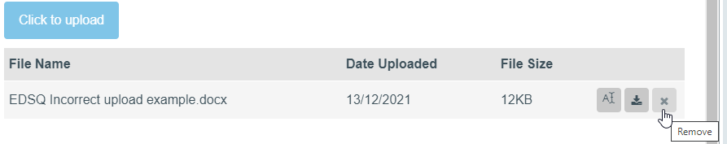

Evidence requirements

In Section B, the learner evidence will consist of:
- tasks performed within the assessment platform
- documents uploaded to the assessment platform
- Witness Observation Record.

All documents should be saved by the learner.

After the assessment

For tasks that require assessor observation, you must use the Witness Observation Record and record the marks in the mark screen in Surpass.

At the end of Section B, the learner will be instructed to click on ‘Finish Test’ to complete their assessment.

Once marking has taken place, all evidence must be stored securely along with the mark scheme.

